Product Mix Model [Lego]
By Jing Zhou
Problem Statement
One of Lego’s production factories in Jiaxing, China is assembling its Lego Star Wars models: A-Wing, X-Wing, and Y-Wing. The models are put together via two assembling processes: 1 and 2. Running process 1 for an hour costs $400 and assembles 300 units of A-Wing, 100 units of X-Wing and 100 units of Y-Wing. Running process 2 for an hour costs $100 and yields 100 units of A-Wing and 100 units of X-Wing. To meet customer demands in time for Christmas Day in the US, at least 1000 units of A-Wing, 500 units of X-Wing and 300 units of Y-Wing must be produced daily.
Objective
To use LP to find the optimal daily production plan that minimizes the cost while meeting Lego’s daily demands.
Solution
The decision variables in this product mix model are fairly obvious. The company must choose two numbers: how many hours to run process 1 and how many hours to run process 2. Once these are known, they can be used, along with the problem inputs, to calculate the cost of meeting daily demand.
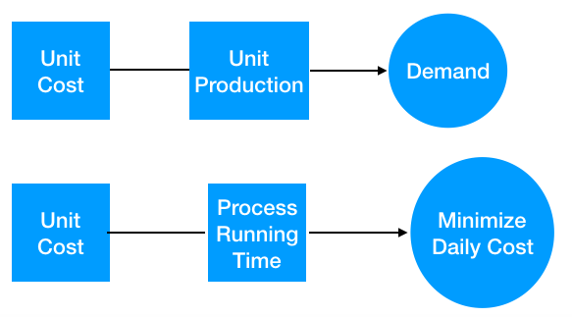
More specifically, first, we need to identify what we are trying to optimize given the problem statement. Our daily production plan must minimize cost of meeting demands. This cost is incurred while running the process. Since we have the hourly cost to run the two process, our production plan should be such that on a given day the combined cost of running the 2 processes to meet the demands of A, B and C stays to a minimum. We know that the objective is to minimize the total cost is which is = (unit cost for running process 1 * number of hours that process 1 is run) + (unit cost for running process 2 * number of hours that process 2 is run). Here the unknowns are number of hours that process 1 is run and number of hours that process 2 is run. Hence, these will be our decision variables. Next, we must ensure that the number of hours that process 1 and process 2 is run is capable pf producing enough of all three products to satisfy their respective demands. This will be part of our constraints in the model.

